[LOGGO]

[NGO]
[Project]

[Report Title]

[Author]
[Audience]
[Date]

Table of Contents
Table of Contents i
List of Figures i
List of Tables i
1. Executive Summary 1
2. Project Data: 2
3. Background / Project Overview 2
4. Objectives and Expected Outcomes 2
5. Activities Implemented 2
6. Achievements vs Planned Results 3
7. Monitoring and Evaluation (M&E) 3
8. Challenges and Lessons Learned 3
9. Beneficiary Feedback and Participation 4
10. Risk Management and Mitigation 4
11. Coordination and Partnerships 4
12. Financial Report 4
13. Visual Documentation 5
14. Recommendations and Way Forward 5
15. Annexes: 6

List of Figures
Figure 1: Sample Photo 5

List of Tables

Table 1: Objectives vs Outcomes 2
Table 2: Activity Details 2
Table 3: Achievement Comparison 3
Table 4: Risk Matrix 4
Table 5: Budget vs Actual 4

Executive Summary

Provide a 1-2 paragraph overview summarizing key activities, achievements, challenges, and recommendations.

Project Data:

[NGO Name]
Project Title: [Insert Project Title]
Donor: [Insert Donor Name]
Reporting Period: [Month/Quarter/Year]
Submitted on: [Date]
Submitted by: [Name & Position]

Background / Project Overview
- Project Location: [District/Province]
- Target Population: [e.g., school children, women, farmers]
- Project Duration: [Start Date – End Date]
- Total Budget: [USD]
- Implementing Partners: [If any]
- Project Objectives:
  - [Objective 1]
  - [Objective 2]

Objectives and Expected Outcomes
[Describe objectives]
Table 1: Objectives vs Outcomes
Objective | Expected Outcome | Indicator | Target | Actual
Obj 1 | [Describe] | [KPI] | [#] | [#]
Obj 2 | [Describe] | [KPI] | [#] | [#]

Activities Implemented
Describe key activities carried out during the reporting period.
Table 2: Activity Details
Activity | Location | Date | Responsible Team | Status
[Name] | [Place] | [dd/mm/yyyy] | [Team] | Completed/In Progress

Achievements vs Planned Results
[Describe the Table]
Table 3: Achievement Comparison
Output | Indicator | Target | Achieved | % Achieved | Remarks
Output 1 | [KPI] | [#] | [#] | [%] | [Note]
Output 2 | [KPI] | [#] | [#] | [%] | [Note]

Monitoring and Evaluation (M&E)
- Tools used: [Kobo, Excel, Survey123, etc.]
- Methods: [FGDs, baseline surveys, pre/post tests]
- Key Findings:
  - [e.g., 85% of students reported improved hygiene knowledge]
  - [e.g., 70% latrine usage rate among girls]

Challenges and Lessons Learned
- Challenges:
  - [e.g., Security restrictions in remote areas]
  - [e.g., Delayed procurement of materials]
- Lessons Learned:
  - [e.g., Early coordination with local leaders improves access]
  - [e.g., Contingency planning essential for logistics]

Beneficiary Feedback and Participation
- Feedback Mechanisms Used: [Help desks, suggestion boxes, surveys]
- Key Feedback Highlights:
  - [Quote from beneficiary]
  - [Observation from feedback report]

Risk Management and Mitigation
[Describe the Table]
Table 4: Risk Matrix
Risk Type | Description | Likelihood | Impact | Mitigation Strategy
Security | [e.g., Taliban presence] | High | High | Coordinate with elders, adjust travel plans
Operational | [e.g., Material shortage] | Medium | Medium | Prequalify backup suppliers

Coordination and Partnerships
- Joint Planning Meetings: [# held, with whom]
- Local Government Involvement: [Yes/No, details]
- Stakeholder Collaboration: [e.g., Ministry of Education, UN agencies]

Financial Report
[Describe the Table]
Table 5: Budget vs Actual
Budget Line | Allocated (USD) | Spent (USD) | Variance | Explanation
Output 1 | 30,000 | 28,500 | -1,500 | Cost-saving on materials
Output 2 | 20,000 | 22,000 | +2,000 | Higher cost due to fuel hike

Visual Documentation
- Attach photos (captioned)
- Charts or graphs showing progress
- Maps of intervention areas (if available)
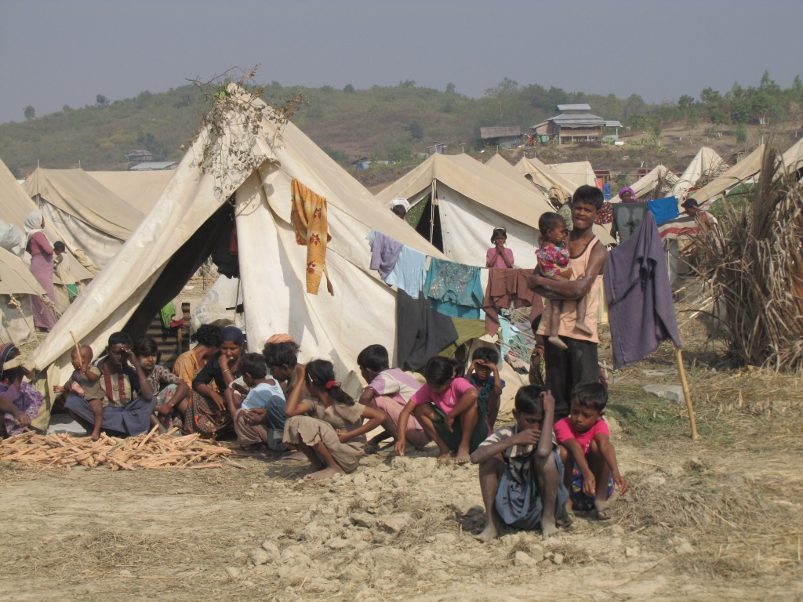
This Photo by Unknown Author is licensed under CC BY-NC-ND
Figure 1: Sample Photo

Recommendations and Way Forward
- [e.g., Scale-up hygiene training to nearby schools]
- [e.g., Establish routine maintenance monitoring]
- [e.g., Plan exit strategy with local authorities]

Annexes:
- Annex 1: Detailed Budget
- Annex 2: Activity Implementation Plan
- Annex 3: M&E Tools
- Annex 4: Photos
- Annex 5: Attendance/Distribution Lists

