TECHNICAL PROPOSAL
CONSTRUCTION OF TEEN CLASSROOM SCHOOL PREMISES WITH WASH AND OTHER FACILITIES IN MURGHAN VILLAGE OF MIRWAIS MINA, KANDAHAR PROVINCE
RFP/COK/2020/001
Submitted by:
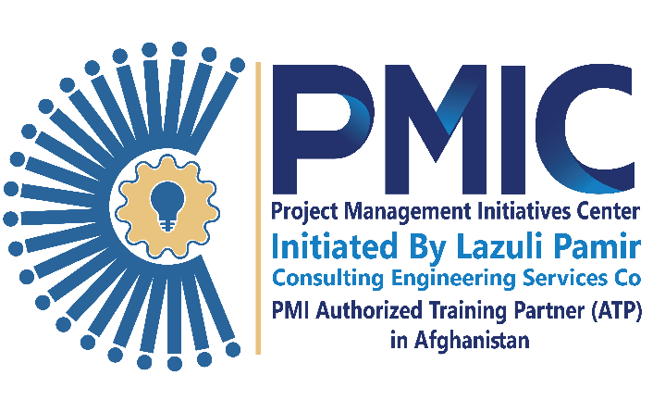

Project Management Initiatives Center (PMIC)
Office: Apartment #405, 4th Floor, Clock Tower, Shahr-E-Naw, Kabul, Afghanistan
Email: pmic@lazulipamir.com
Website: www.lazulipmic.com
Mobile: +93 (0) 74905531
Submission:

UNHCR,
Procurement Department
Afghanistan Country Office
Kabul, Afghanistan

Closing Date: 01 March 2025 – 04:00 PM, Kabul, Afghanistan Time

Table of Contents

REGISTRATION LICENSE: 3

LETTER TO TECHNICAL PROPOSAL: 4

SITE VISIT PHOTOS: 6

YEARS OF EXPERIENCE: 7

ORGANIZATION STRUCTURE: 8

PAST GENERAL EXPERIENCE: 9

PAST SIMILAR EXPERIENCES: 10

TURNOVER: 11

PROPOSED APPROACH AND METHODOLOGIES: 12

PROJECT SCHEDULE: 13

PROJECT ASSUMPTIONS AND CONSTRAINTS: 14

PROJECT CHALLENGES AND RISKS: 15

LIST OF EQUIPMENT: 16

LIST OF KEY PERSONNEL: 17

FINANCIAL CAPABILITIES: 18

VENDOR REGISTRATION FORM: 19

COMPANY PROFILE: 20

COMPANY POLICIES: 21

SIGNED & STAMPED BIDDING DOCUMENTS: 22

REGISTRATION LICENSE:
"Please attach the updated license of registration for your company here, or you can attach it separately to your proposal."

LETTER TO TECHNICAL PROPOSAL:
[Your Company Letterhead]

[Date]

[Recipient's Name]
[Recipient's Title]
[Company Name]
[Company Address]

Dear [Recipient's Name],
Subject: Technical Proposal Submission for [Project Name]
We are pleased to submit our technical proposal for the [Project Name] in response to your request for proposal dated [Date of RFP]. We believe that our expertise and experience make us well-suited to meet the requirements outlined in the RFP.

Our technical proposal outlines in detail our approach, methodology, and solutions for addressing the challenges and achieving the objectives of the project. We have carefully crafted our proposal to demonstrate how our capabilities align with the specific needs and goals outlined by your organization.
Please note the following important points regarding our proposal:
- Validity Date: The validity period of our proposal is [Insert Validity Date]. This means that the terms and conditions outlined in our proposal are valid until this date. Should you require an extension of the validity period, please do not hesitate to contact us.
- Acceptance of Rules and Conditions: By accepting our proposal, you agree to abide by the rules and conditions outlined in the contract documents provided by your organization. We are committed to fulfilling our obligations as outlined in the contract and ensuring the successful completion of the project.

We would like to express our enthusiasm for the opportunity to collaborate with your organization on this project. We are confident that our technical expertise and dedication to excellence will contribute to the success of the project.

Thank you for considering our proposal. Should you have any questions or require further information, please feel free to contact us at [Your Contact Information].

We look forward to the possibility of working together.

Sincerely,
[Your Name]
[Your Title]
[Your Company Name]

SITE VISIT PHOTOS:
"Please ensure that the technical proposal includes site photos or a site visit certificate, as many organizations require a site visit to be conducted as a mandatory part of the proposal submission process."

YEARS OF EXPERIENCE:
"In this section, please specify the number of years of experience your team has in this specific field."

ORGANIZATION STRUCTURE:
"Incorporate the organizational structure and emphasize the project team assigned to this project within this structure."

PAST GENERAL EXPERIENCE:
"Incorporate a table detailing all past projects in this section. Additionally, if requested by the employer, attach copies of contracts and certificates related to these projects."

PAST SIMILAR EXPERIENCES:
"Include a table listing similar projects as required in the RFP. If requested, attach copies of contracts and completion certificates for these projects."

TURNOVER:
"Fill in this table with details of similar projects as required in the RFP. If requested, attach copies of contracts and completion certificates for these projects. Additionally, include the turnover of your company for each year as per your financial audited statements."

PROPOSED APPROACH AND METHODOLOGIES:
"Incorporate within the technical approach and methodology section the strategies that your company and team intend to implement for the successful execution of the project. This section should also encompass a clear understanding of the project scope, demonstrating to the employer that your team comprehends the project's objectives and requirements. Provide a detailed explanation of how your proposed approach aligns with the project's goals and how it addresses the identified challenges and constraints. Ensure to highlight the key steps, methodologies, tools, and technologies that will be utilized throughout the project lifecycle. Additionally, emphasize any unique insights or innovative approaches that your team brings to the table to ensure project success."

PROJECT SCHEDULE:
Prepare a project work plan and implementation plan in a Gantt chart format using one of the following software options:
a. MS Project b. Primavera c. MS Excel
Ensure to adhere to the following guidelines:
- Review the RFP to determine the allocated time for the project.
- Develop a realistic plan that considers all necessary tasks and dependencies.
- Ensure that the total duration of the plan does not exceed the timeframe specified in the RFP.
- Include milestones at key points in the project timeline.
- Consider additional project requirements and constraints as specified in the RFP.

PROJECT ASSUMPTIONS AND CONSTRAINTS:
Draft project assumptions and constraints to establish a framework for mitigating risks and ensuring project success. By clearly defining these factors, you can safeguard against potential failures in the future.

PROJECT CHALLENGES AND RISKS:
Develop a comprehensive analysis of project risks and challenges to proactively address potential pitfalls and uncertainties. By identifying and strategizing around these factors, you can bolster project resilience and mitigate the likelihood of failure.

LIST OF EQUIPMENT:
"Include the list of equipment specified in the RFP, ensuring that it aligns with the project requirements and objectives."

LIST OF KEY PERSONNEL:
"Include the list of personnel specified in the RFP, ensuring that it aligns with the project requirements and objectives."

FINANCIAL CAPABILITIES:
"Incorporate the bank statement, bank letter, or any other relevant evidence to demonstrate the financial capability of your company to undertake this project."

VENDOR REGISTRATION FORM:
"If applicable, complete and include the vendor registration form as required."

COMPANY PROFILE:
"If stipulated in the RFP, please attach your company profile for further reference."

COMPANY POLICIES:
"Review your RFP and attach the policies of your company, including:
- Safety Policy
- Anti-Plagiarism Policy
- Environmental Policy
- Quality Control / Quality Assurance Policy.
Ensure that these policies align with the requirements and standards outlined in the RFP."

SIGNED & STAMPED BIDDING DOCUMENTS:
"If required by the RFP, ensure that all bidding documents, including drawings, specifications, rules, regulations, and contract conditions, are signed and stamped as per the employer's instructions."

